Day 96: Kubernetes
Amazon ECS
Day 97: Kubernetes (K8s)
What is Kubernetes?
Kubernetes is an open source container orchestration tool developed by google to help you manage the containerised / dockerised application supporting multiple deployment environments like on premise, cloud, or virtual machines.
Kubernetes is often called "K8s" because it's a shortened version, where the "8" represents the eight letters between the "K" and the "s" in the full name, "Kubernetes"

What are the main features of K8s offers?
1. Assures high availability with zero down time
2. High performance and scalable
3. Reliable infrastructure to support data recovery
Disadvantages: it is very complex or takes lot of time for setting up the k8s infra
Kubernetes architecture
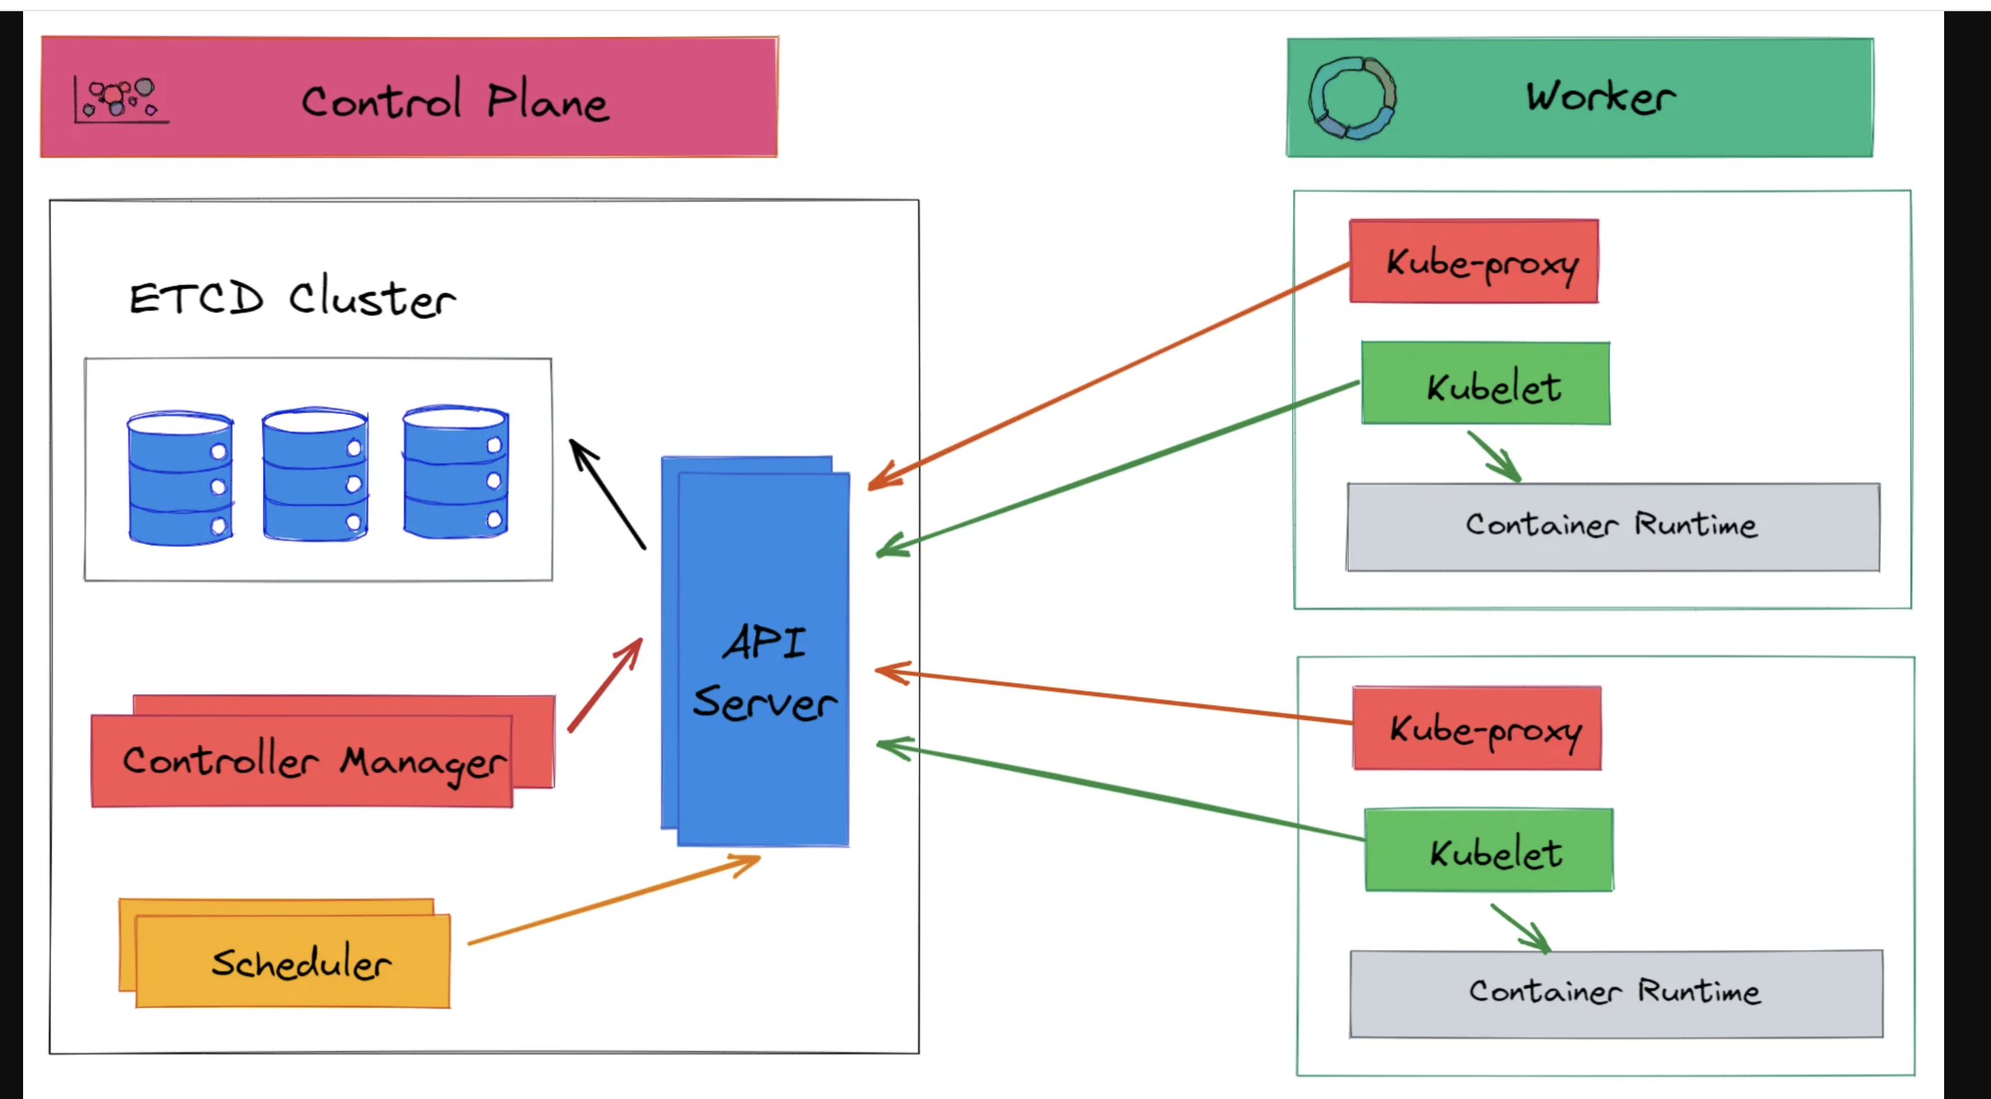

Kubernetes cluster has two major components:
1. Control Plane/ Master node
2. Worker node
Node: physical machine or virtual worker machine where containers will be deployed by k8s.
Cluster: set of nodes grouped together.
Master or control panel manages the cluster

Kubernetes Architecture:
Kubernetes has two nodes – master node and worker/slave node.
Master node:
The master node is the first and most vital component which is responsible for the management of Kubernetes cluster. it is the entry point of all kind of administrative tasks. there might be more than one master node in the cluster to check for fault tolerance.
The master node has various components like API server, Controller manager, kubectl, scheduler and ETCD.
ETCD:
• This component stores the configuration details and essential values in key value form
{
“name”: “xyz”,
“part”: “ght”
}
• It communicates with all other components to receive the commands to perform an action.
• It is also called as meta data storage.
Controller Manager:
• A daemon (server) that runs in continuous loop and is responsible for gathering information and sending it to the API server.
• Works to get the shared set of clusters and change them to the desired state of the server.
• The key controllers are the replication controllers, endpoint controllers, namespace controllers and service account controllers.
• The controller manager runs controllers to administer nodes and endpoints.
Scheduler
• The Schedular assigns the tasks to the slave nodes.
• It is responsible for distributing the workload and stores resource usage information on every node.
API Server
• Kubernetes uses the API server to perform all operations on the cluster.
• It is central management entity that receives all REST requests for modifications, serving as frontend to the cluster.
Kubectl
• Kubectl controls the Kubernetes cluster manager.

Worker/Slave nodes
Worker nodes are another essential component which contains all the required services to manage the networking between the containers, communicate with the master node, which allows you to assign resources to the scheduled containers.
- Kubelet: gets the configuration of a Pod from the API server and ensures that the described containers are up and running
- Docker Container: Docker container runs on each of the worker nodes, which runs the configured pods.
- Kube-proxy: Kube-proxy acts as a load balancer and network proxy to perform service on a single worker node.
- Pods: A pod is a combination of single or multiple containers that logically runs together on nodes.
Pods:
Pods are smallest objects which can be created in Kubernetes cluster.
In terms of docker concepts, a pod is similar to a group of docker containers with shared namespace and shared file system volumes.
Day 98: Kubernetes (K8s)
Kubernetes installation
Please refer to the installation doc
“Kubernetes bare metal installtion doc”
Day 99: Kubernetes (K8s)
Pods:
Pod is collection of containers, we create the pod and containers will be created and managed by the Kubernetes.
Jenkinspod.yml
apiVersion: v1
kind: Pod
metadata:
name: Jenkins
labels:
app: test
spec:
containers:
- name: jenkins
image: jenkins/jenkins:latest

Note:
apiVersion – this is used to specify the api version,the calls which we get from the api server. For pod we always use v1
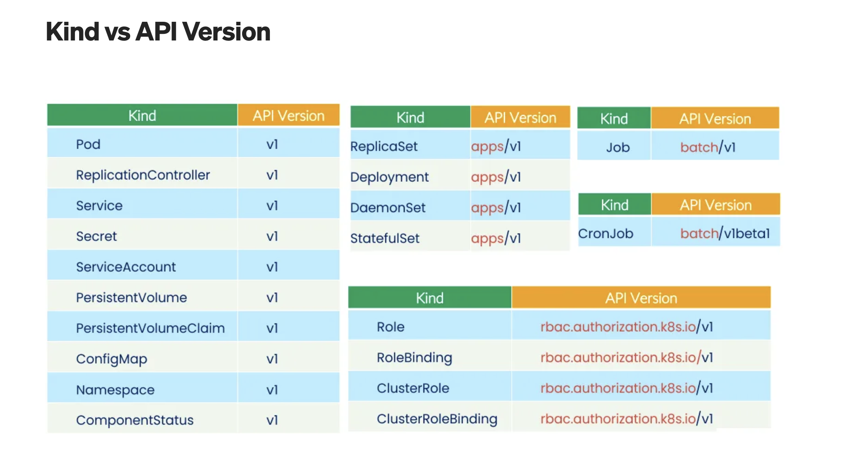
kind – this is used to let Kubernetes know that we want to create a pod, the other available options are Node, Deployment, Service, ReplicaSet, Namespace, Persistent volume etcc.,
metadata – this is used to specify the information of the pod
name – this is used to specify the name of the POD, we can also use labels, namespace,UID, Annotation etc.., here.
spec – it stands for specifications, under spec we can create containers(name, image, port, etc..,)

To create the pod:
Kubectl create -f jenkinspod.yml
Kubectl apply -f jenkinspod.yml

When we run the above command, an API request will be sent to the API server, which will internally check with the etcd about the pod, if the pod details exist in the etcd, then it will throw an error stating, the pod already exist.
If the pod is not present in the etcd, then with the help of controller manager and scheduler, it will create a pod on the worker nodes

Note: /root/.kube/config
Copy paste the config file with .kube directory under any user to have the permission to run the kubectl commands

- Once we use the create/apply command, it will create a container on the worker node.
- To get the pod info
kubectl get pods
kubectl get pods -A
- If we have multiple worker nodes, then we are not sure on which node, the container will be created.
- Use the below command, to get more info of the pod, like IP address of the pod, node IP, etc..,
kubectl get pods -owide
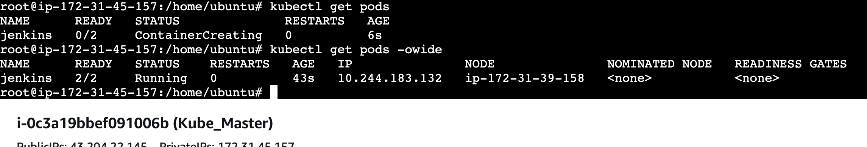
- On the worker node we can use the below commands to check the containers and logs of the container
sudo crictl ps
sudo crictl ps -a
sudo crictl logs containerID
- We can check the logs on the master node as well
kubectl logs pod_name
Example:
kubectl logs Jenkins
- If we have multiple containers on the pod, then the above command will only show the logs for the default or first container. If we want the logs of a specific container use the below command.
kubectl logs pod_name -c container_name
Example:
kubectl logs Jenkins -c jenkins
- To delete the pods
kubectl delete pod pod_name
kubectl delete -f yaml_filename
Example:
kubectl delete pod Jenkins
kubectl delete -f jenkinspod.yml

- Lifecycle of a POD
  - Pending
  - Container creating
  - Running
  - Terminating
- You can use the below command to watch the pod lifecycle
  - kubectl get pods -w

Namespaces:
- It’s a pod isolation
- The namespaces which are created by Kubernetes are
  - default
  - kube-node-lease
  - kube-public
  - kube-system
- on default, our pods will be running
- on kube-system, the architecture components(API, ETCD, Sechduler, Conrtoller, etc..,) will be running
- f
- We can create a custom namespace
kubectl create namespace name
kubectl create namespace testnamespace
- We can use the below command to create a pod on a custom namespace
kubectl create -f filename -n namespacename
kubectl create -f jenkinspod.yml -n testnamespace
- When we use the get pods command, it will fetch the pods from the default namespace.
- If we want to list the pods from a custom namespace use the below command
kubectl get pods -n namespace_name
kubectl get pods -n testnamespace

- Notes:
- Namespaces:
Namespace helps in creating a virtual cluster inside your Kubernetes cluster
Namespace helps you isolate your resources between different teams. Allocate resources or apply quota of resources
- Advantages of namespace:
-- Helps in easy management of applications of each environment
-- Control multiple app with single name in a single cluster
-- Cost effective

- Default k8s namespaces are.
Default: adding an object to a cluster without providing a namespace will place it within the default namespace
Kube-system: kube system namespace is used for k8s components managed by k8s
Kube-public: kube public it is readable by everyone, but the namespace is reserved for system usage

Day 100: Kubernetes (K8s)
Services
In Kubernetes (K8s), a Service is an abstraction that defines a logical set of Pods and a policy by which to access them, providing a stable endpoint for communication and enabling service discovery, load balancing, and external traffic exposure

K8s service type allows you to specify what kind of service you want, the default is cluster IP
Type values and their behaviours are:
1. ClusterIP: Exposes the service on a cluster internal IP. Using this value makes the service only reachable from within the cluster. This is the default service type.
2. NodePort: exposes the service on each nodes IP at a static port.
A cluster IP service, to which the nodes port service routes are automatically created.
3. LoadBalancer: exposes the service externally using a cloud providers load balancer.
Node port and cluster IP services, to which the external load balancer routes are automatically created.
4. ExternalName/ExternalIP: maps the service to the content of external fields by written a C name records within a value.

jenkinspod.yml
apiVersion: v1
kind: Pod
metadata:
name: jenkins1
labels:
my-pod: Jenkins
spec:
containers:
- name: jenkins
image: jenkins/jenkins:latest

jenkins-service.yml
apiVersion: v1
kind: Service
metadata:
name: jenkinsservice
spec:
selector:
my-pod: Jenkins
ports:
- protocol: TCP
port: 8080
targetPort: 8080

- In services, we will be using the labels which are called as selectors which is used to map the pods to the service
- We won’t be using the pod IP anymore, instead we will use the service IP.
- Service will distribute the load across the pods
- If we have multiple pods which are mapped to the service and when we hit the service IP, the request will be routed to the one of the PODs.
- First we need to create the pod and get the labels
  - kubectl create -f jenkinspod.yml
  - kubectl get pods --show-labels
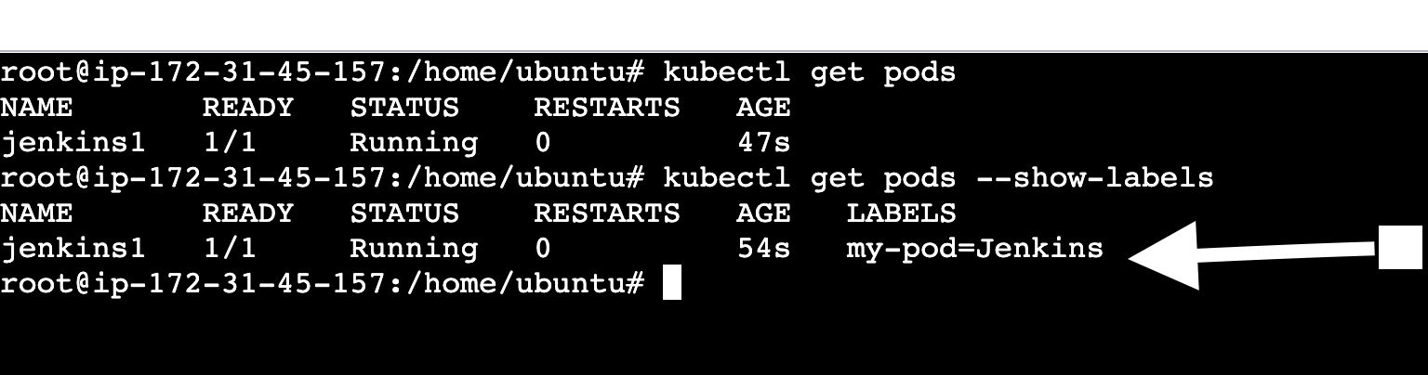
- We need to use the same label name in the service manifest file under spec.
- This will map the pod to the service
- Commands to create a service
  - kubectl create -f filename.yml
  - kubectl apply -f filename.yml
  - Example:
  - kubectl create -f jenkins-service.yml
  - kubectl apply -f jenkins-service.yml

- To see the services
  - Kubectl get services
  - Kubectl get svc
  - Kubectl get svc -o -wide
- If we want to look at the pod Ips to which the service is pointing to, we can use the below command:
  - Kubectl get endpoints
  - Kubectl get pods -o wide
Types of services
- ClusterIP – the application is accessible only with in the cluster
- NodePort – the application is accessible from the outside world
- LoadBalancer – It will create an external load balancer to balance the load
- The clusterIP is the default service which will be created if we don’t specify it in the yml file.
- By default k8s will create a service called as Kubernetes which will of type clusterip
- If we want to create different types of services, we need to specify it in the yml file under the spec
- NodePort:
jenkins-service-nodeport.yml
apiVersion: v1
kind: Service
metadata:
name: jenkinsservice-nodeport
spec:
type: NodePort
selector:
my-pod: Jenkins
ports:
- protocol: TCP
port: 8080
targetPort: 8080
nodePort: 30008

- When we use the nodeport service, we need to specify the nodeport.
- We will be using this port to access the application
- The available node ports are 30000-32767
- We can use the below command to access the application from outside world
  - Publicip of the machine:30008
  - http://13.201.136.219:30008/
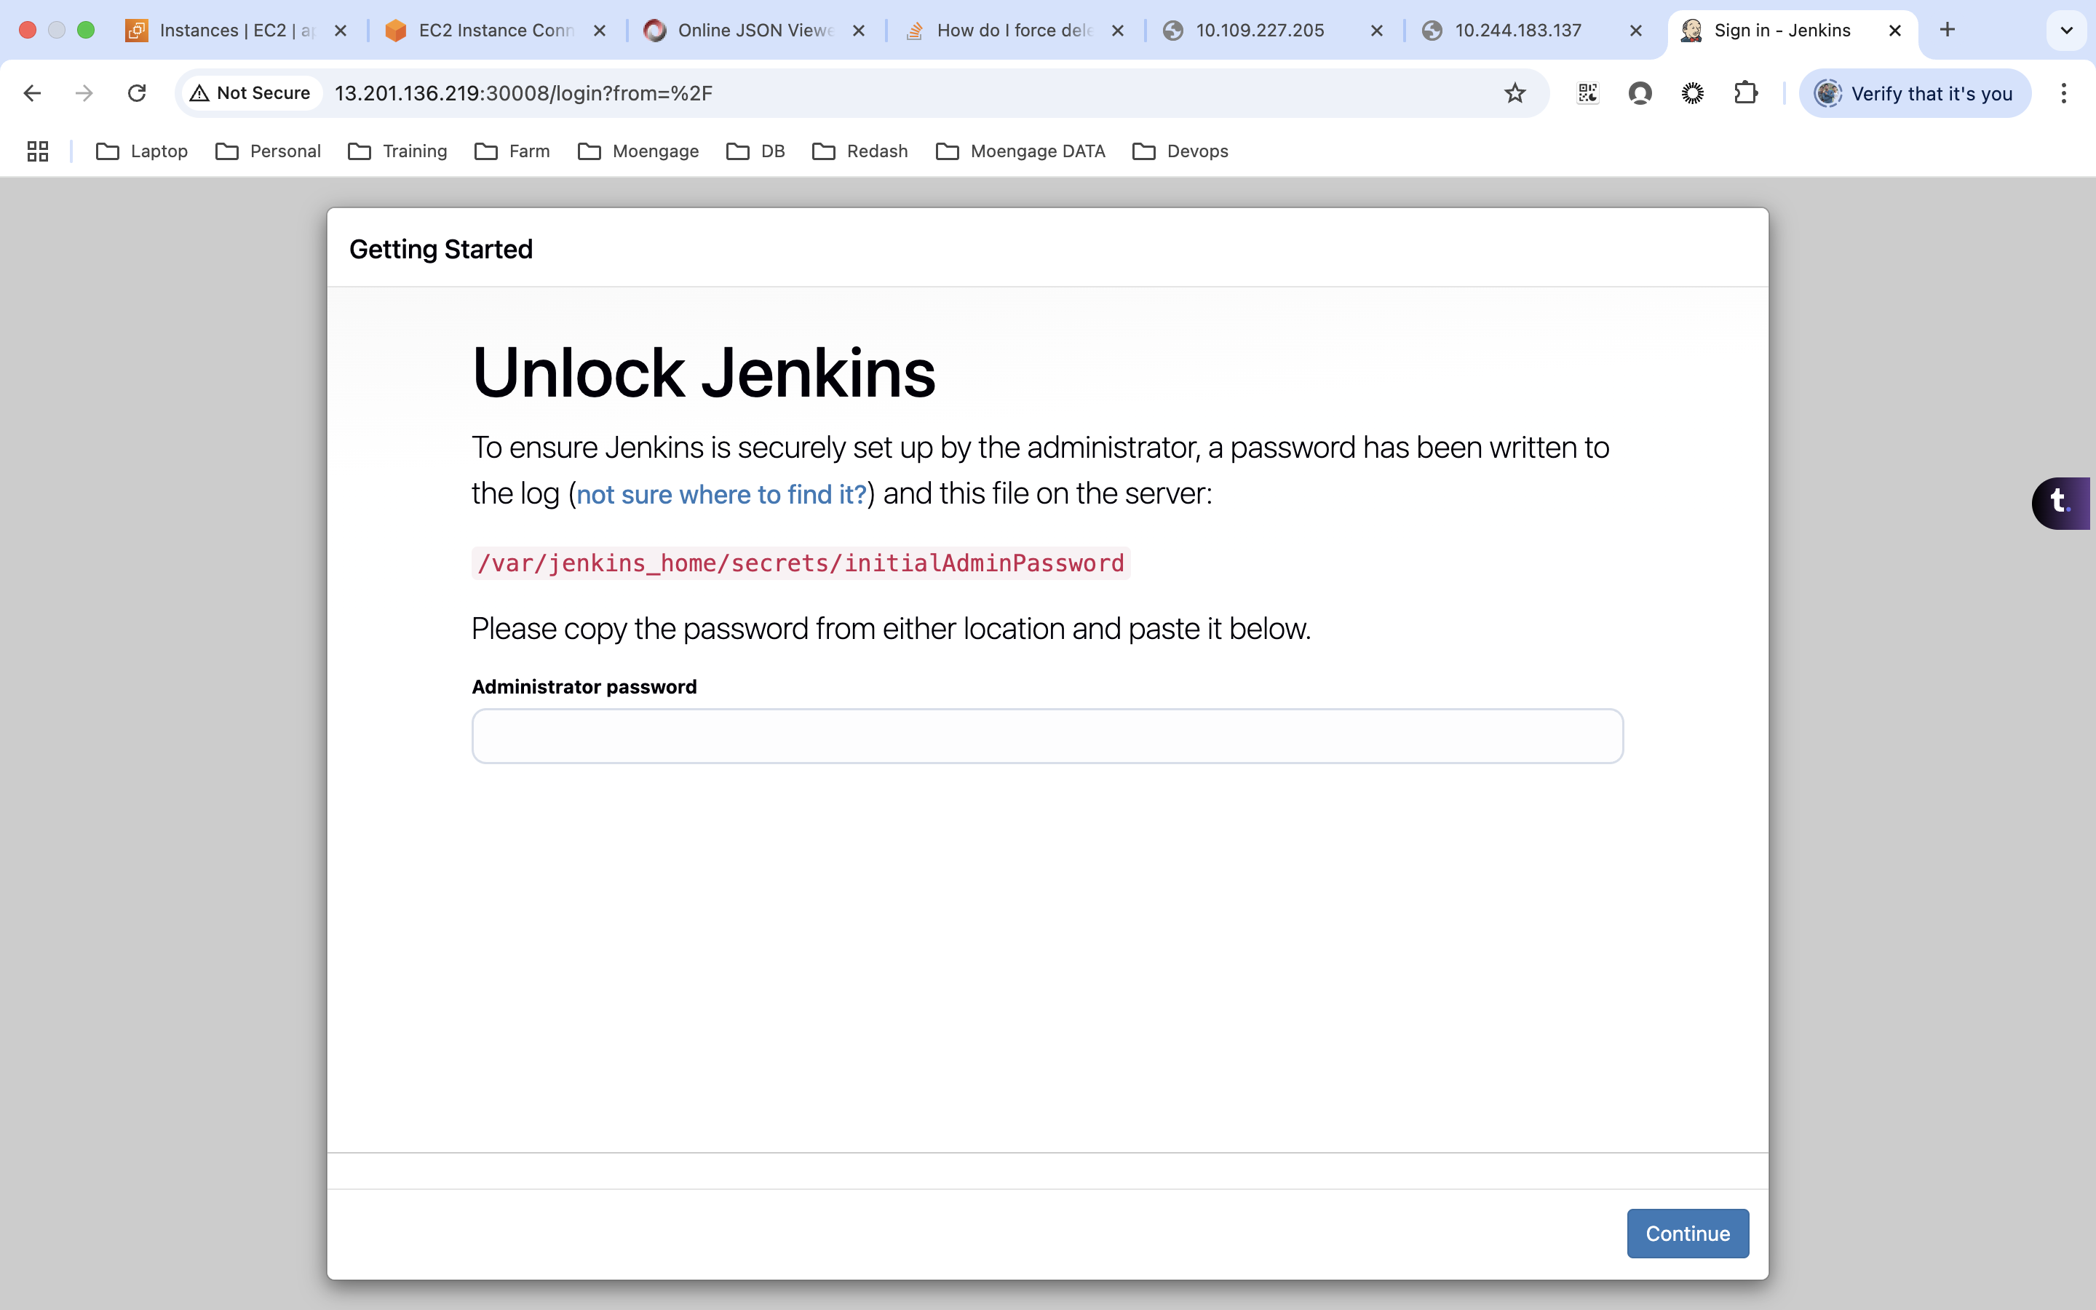

- LoadBalancer
jenkins-service-loadbalancer.yml
apiVersion: v1
kind: Service
metadata:
name: jenkinsservice-loadbalancer
spec:
type: LoadBalancer
selector:
my-pod: Jenkins
ports:
- protocol: TCP
port: 8080
targetPort: 8080

- To use the LoadBalancer service we need to have a cloud setup

- External Ips:

jenkins-service-externalIP.yml
apiVersion: v1
kind: Service
metadata:
name: jenkinsservice-extrenal-ip
spec:
selector:
my-pod: Jenkins
ports:
- name: http
protocol: TCP
port: 8082
targetPort: 8080
externalIPs:
- 172.31.45.157

- ExternalName:
jenkins-service-externalname.yml
apiVersion: v1
kind: Service
metadata:
name: google-service
spec:
type: ExternalName
externalName: google.com

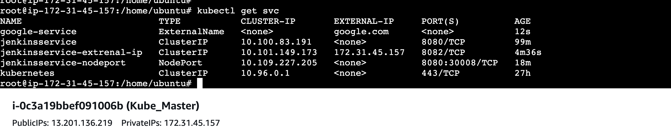

Day 101: Kubernetes (K8s)
Cloud setup – Please refer to the ‘Kubernetes cloud setup.doc’
Loadbalancer
- As we know the load balancer will only work on cloud, the reason is it will try to create an external load balancer

jenkins-service-loadbalancer.yml
---
apiVersion: v1
kind: Pod
metadata:
name: jenkins1
labels:
my-pod: Jenkins
spec:
containers:
- name: jenkins
image: jenkins/jenkins:latest
---
apiVersion: v1
kind: Service
metadata:
name: jenkinsservice-loadbalancer
spec:
type: LoadBalancer
selector:
my-pod: Jenkins
ports:
- protocol: TCP
port: 8080
targetPort: 8080

- Here the we map the pod and service with the label
- This will create an external load balancer on the cloud platform
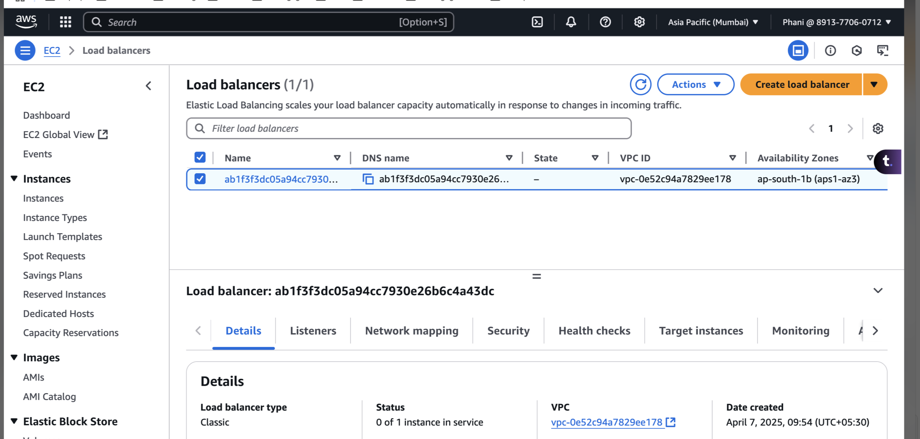
- Kubectl create -f jenkins-service-loadbalancer.yml
- Kubectl delete -f jenkins-service-loadbalancer.yml
Replicaset:
jenkins_replicaset.yml
apiVersion: apps/v1
kind: ReplicaSet
metadata:
name: jenkins-replicaset
namespace: default
spec:
replicas: 2
selector:
matchLabels:
my-pod: my-jenkins
template:
metadata:
labels:
my-pod: my-jenkins
spec:
containers:
- name: jenkins
image: jenkins/jenkins:latest

- ReplicaSet is used for auto healing
- When we specify the replicas as any number(for example 2), the specified number of pods will be keep on running.
- If any of the pods is down, it will immediately create a new one so that it will match the specified number
- Even if we manually delete the pod, it will create one more pod
- It uses app version as app/v1 and the label is used to map between the replicaset and pod
- Here pods will be controlled by the replicaset
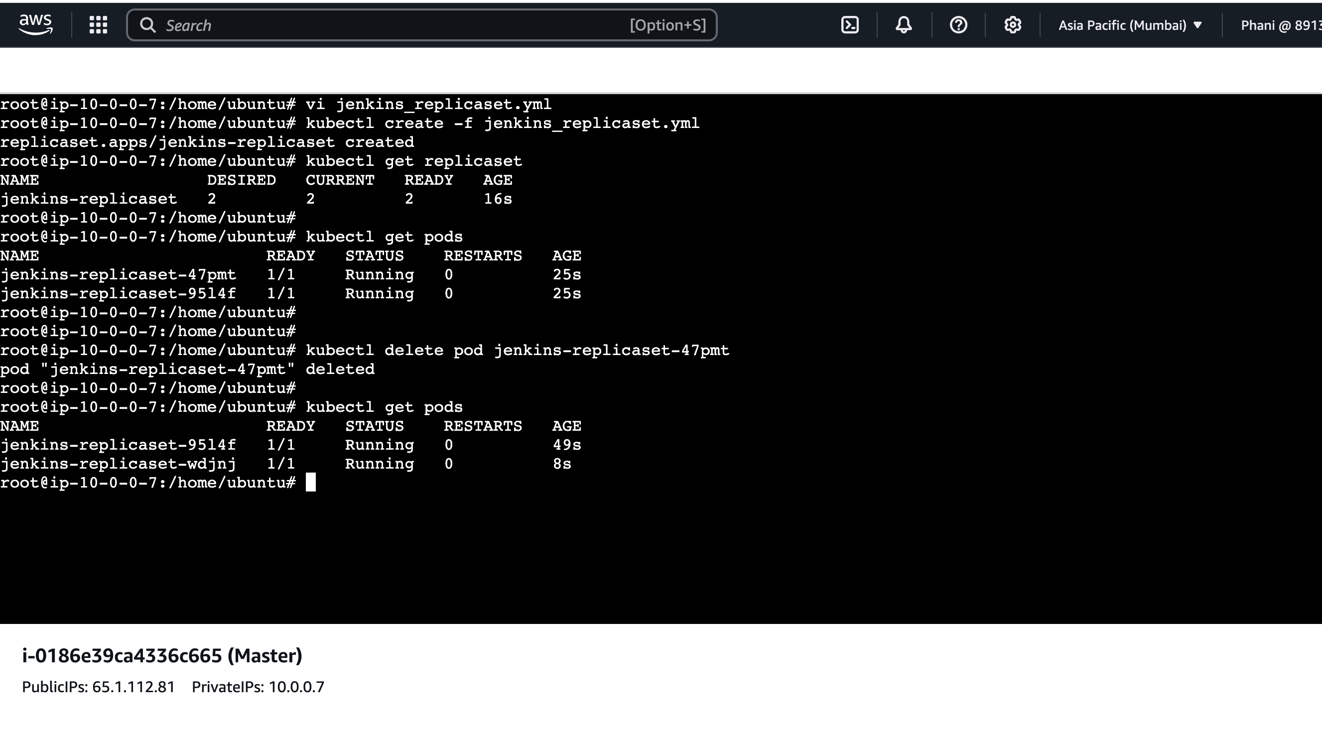
- kubectl create -f jenkins_replicaset.yml
- kubectl get replicaset
- kubectl get pods
- kubectl delete pod jenkins-replicaset-47pmt
- kubectl get pods
- Kubectl delete replicaset jenkins_replicaset
Service:
jenkins_replicaset_service.yml
apiVersion: apps/v1
kind: ReplicaSet
metadata:
name: jenkins-replicaset
namespace: default
spec:
replicas: 2
selector:
matchLabels:
my-pod: my-jenkins
template:
metadata:
labels:
my-pod: my-jenkins
spec:
containers:
- name: jenkins
image: jenkins/jenkins:latest

---
apiVersion: v1
kind: Service
metadata:
name: jenkinsservice-nodeport
spec:
type: NodePort
selector:
my-pod: my-jenkins
ports:
- protocol: TCP
port: 8080
targetPort: 8080
nodePort: 30008

- Here we are mapping a service(nodeport) to the replicaset
- vi jenkins_replicaset_service.yml
- kubectl create -f jenkins_replicaset_service.yml
- kubectl get svc
- kubectl get replicaset
- kubectl get endpoints
- kubectl get pods
- kubectl get pods -owide
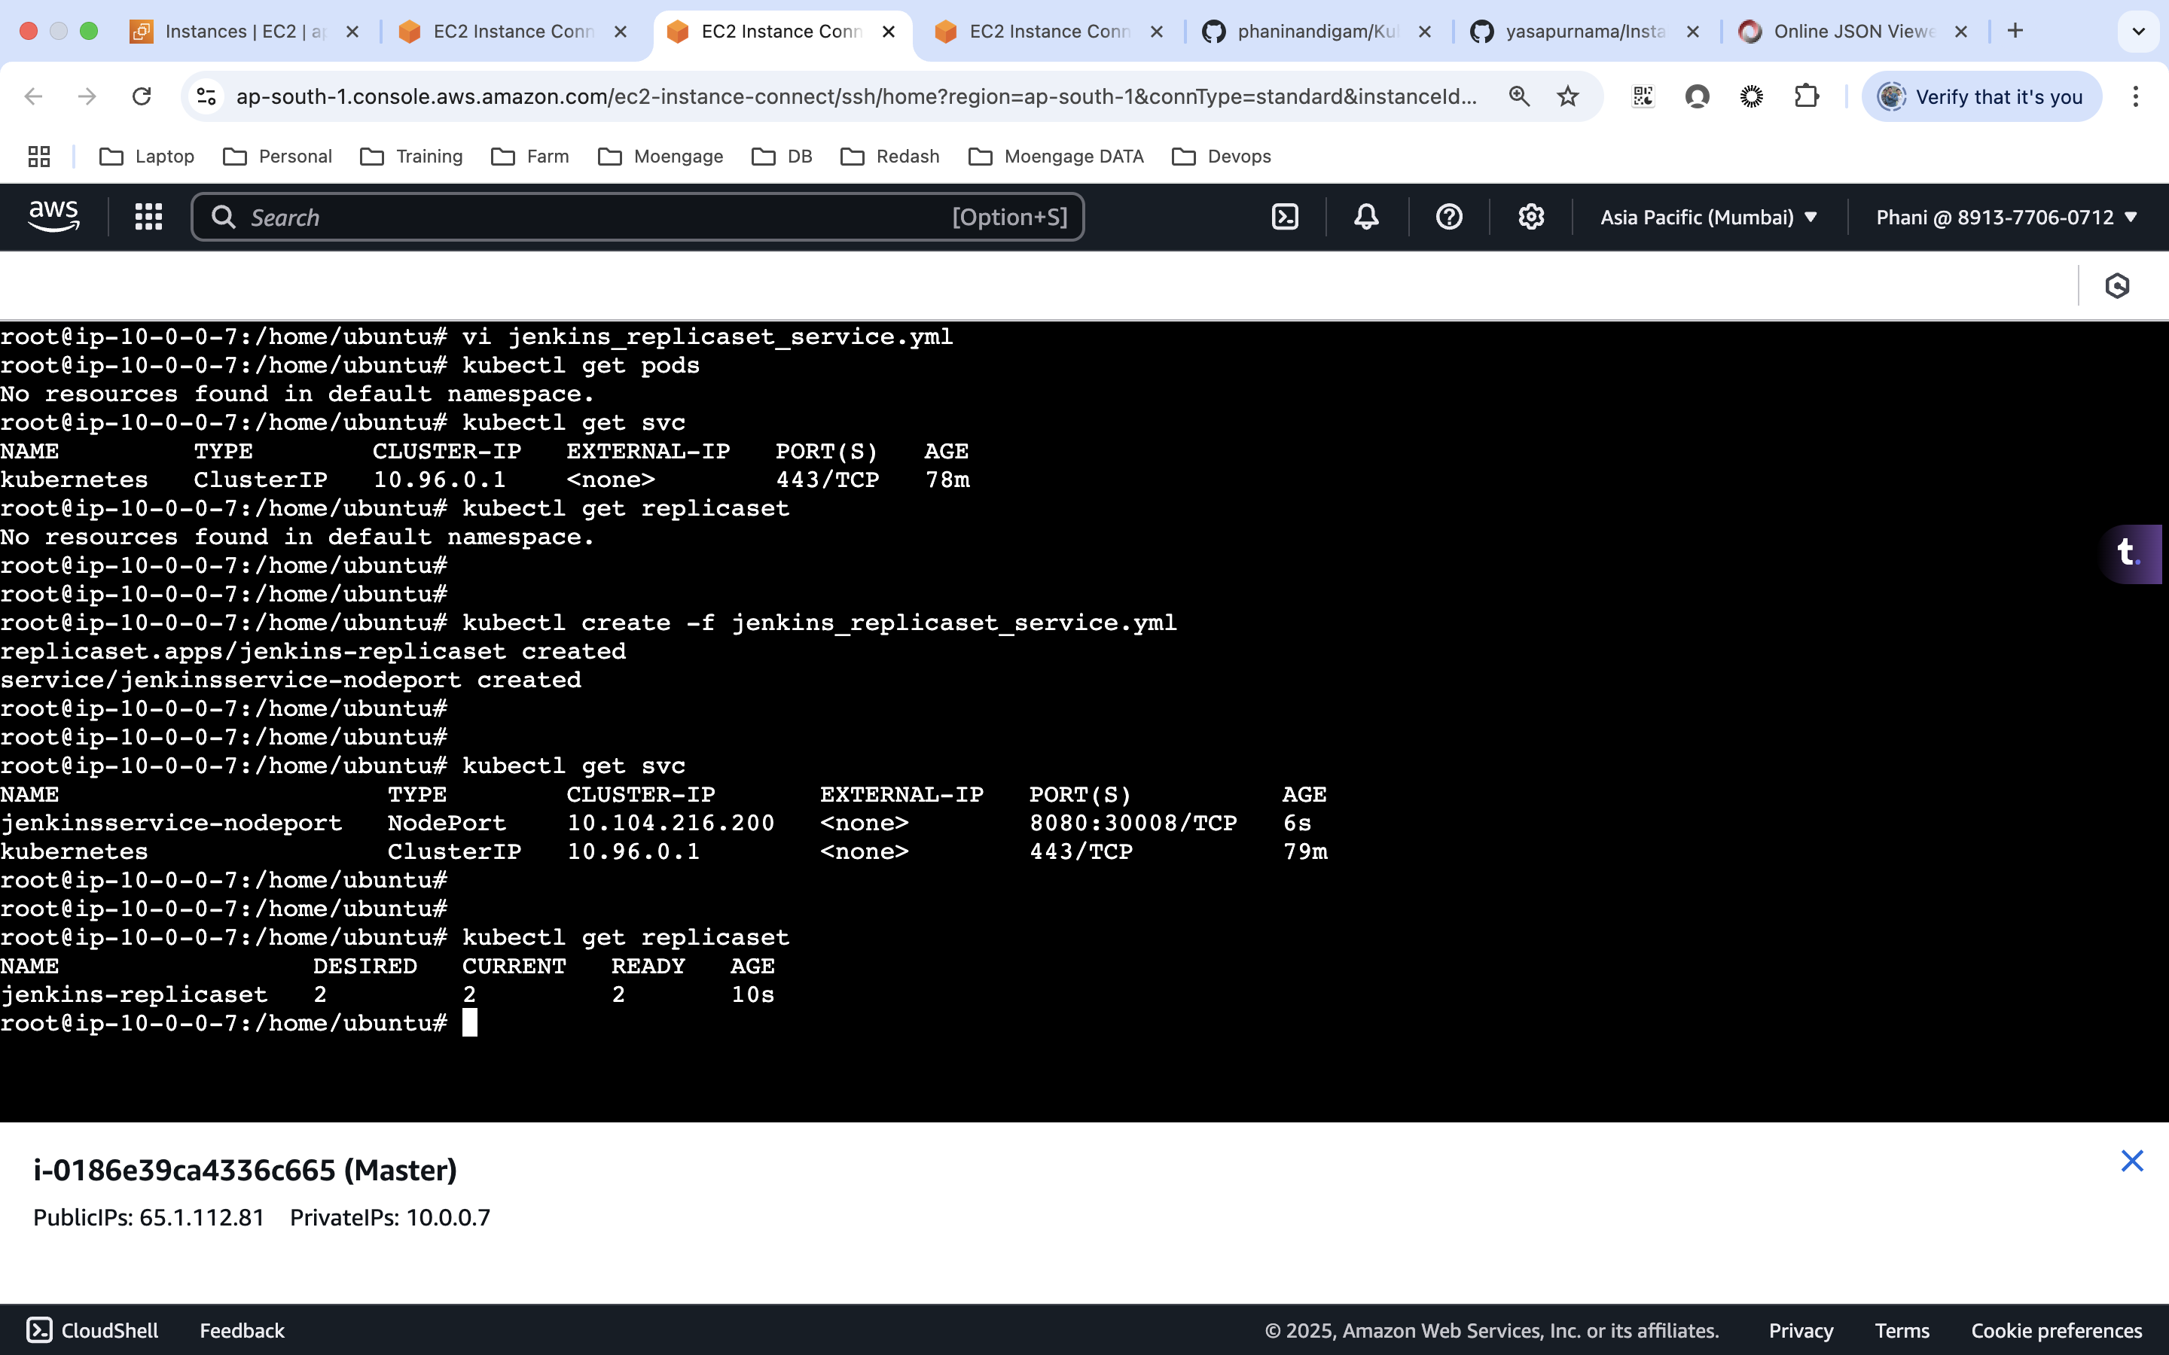

Day 102: Kubernetes (K8s)
Deployment:
jenkins_deployment.yml
apiVersion: apps/v1
kind: Deployment
metadata:
name: jenkins-replicaset-deployment
labels:
app: my-jenkins
spec:
replicas: 4
strategy:
type: RollingUpdate
rollingUpdate:
maxSurge: 2
maxUnavailable: 0
selector:
matchLabels:
app: my-jenkins
template:
metadata:
labels:
app: my-jenkins
spec:
containers:
- name: jenkins
image: jenkins/jenkins:latest

- The deployment will make sure that we have a rolling updates on 2 and once those are successful we will process with the rest. At a time only 2 will be updated as mentioned on the yml file
- Internally, it will create a new replicaset and once all the pods are running on the new replicaset, then the old one will be deleted.
- The 2 major components we need to look here is maxSurge and maxUnavailable
- maxSurge will define on how many pods we can apply the updates at a time. Lets assume we have 10 pods and maxSurge as 2, then first it will try to update 2 pods and once they are successfully and are in running state (it will terminate the pods on the old replicate set), it will proceed with 2 more and so on. Once all the pods are in running state the old replicate state will be deleted.
- maxUnavailable will define how many pods can be in any state apart from running while running the updates. Let’s we have 4 pods and out of which we have 1 pod is in creating state and if we define the maxUnavailable as 0, then it won’t update the pods. The reason is all the pods have to be on running state.
- If we define the maxUnavailable as 1, then it will look only for 3 pods. If 3 pods are running state, it will be good enough to update the pods.
- kubectl create -f jenkins_deployment.yml
- kubectl get pods
- kubectl get replicaset
- kubectl get deployment
- kubectl describe deployment deployment_name
- kubectl get all
- kubectl delete deployment deployment_name

DaemonSet:
jenkins_daemonset.yml
apiVersion: apps/v1
kind: DaemonSet
metadata:
name: jenkins-daemon
labels:
app: my-daemon
spec:
selector:
matchLabels:
app: my-daemon
template:
metadata:
labels:
app: my-daemon
spec:
containers:
- name: jenkins
image: jenkins/jenkins:latest

- The daemonset will make sure each node has one pod
- Let’s assume if we have 10 worker nodes, each node will have one pod deployed on each of them.
- Even if we try to add one more node, it will automatically add the pod to the newly created node.
- Kubectl create -f jenkins_daemonset.yml
- Kubectl get daemonset
- Kubectl describe daemonset daemonset_name
- Kubectl get pods
- Kubectl delete daemonset daemonset_name

Day 103: Kubernetes (K8s)
Resource quota
12_reservedquota.yml
apiVersion: v1
kind: ResourceQuota
metadata:
name: namepsace-resourcequota
namespace: test-namespace
spec:
hard:
pods: "3"

13_reservedquota_CPU.yml
apiVersion: v1
kind: ResourceQuota
metadata:
name: namepsace-resourcequota1
namespace: test-namespace
spec:
hard:
pods: "3"
requests.cpu: "1"
requests.memory: 1Gi
limits.cpu: "2"
limits.memory: 2Gi

Limit range
14_limitrange.yml
apiVersion: v1
kind: LimitRange
metadata:
name: limitrange
namespace: test-namespace
spec:
limits:
- default:
cpu: 1
memory: 500Mi
defaultRequest:
cpu: 0.4
memory: 250Mi
type: Container

15_reourcelimit_podlevel.yml
apiVersion: apps/v1
kind: Deployment
metadata:
name: jenkins-replicaset-deployment
labels:
app: my-jenkins
spec:
replicas: 5
strategy:
type: RollingUpdate
rollingUpdate:
maxSurge: 2
maxUnavailable: 0
selector:
matchLabels:
app: my-jenkins
template:
metadata:
labels:
app: my-jenkins
spec:
containers:
- name: jenkins
image: jenkins/jenkins:latest
resources:
limits:
memory: "500Mi"
cpu: 1
requests:
memory: "250Mi"
cpu: 0.4

Guaranteed, burstable and best effort
Limit Request
Same Same Guaranteed
More less Bustable
No limit no request Best effort
Day 104: Kubernetes (K8s)
Taint
Kubectl taint node nodename key=value:noSechedule
Kubectl taint node nodename env=dev:noSechedule

Nosechedule
No execute
Prefer Nosechedule
To remove the taint:
Kubectl taint node nodename env=dev:noSechedule-
https://github.com/pavans78/k8s-nodeAffinity-examples/blob/main/nodeAffinity-pre-req.yaml
https://github.com/infracloudio/kubernetes-scheduling-examples/blob/master/podAffinity/deployment-Affinity.yaml

tolerations
apiVersion: apps/v1
kind: Deployment
metadata:
name: jenkins-replicaset-deployment
labels:
app: my-jenkins
spec:
replicas: 5
strategy:
type: RollingUpdate
rollingUpdate:
maxSurge: 2
maxUnavailable: 0
selector:
matchLabels:
app: my-jenkins
template:
metadata:
labels:
app: my-jenkins
spec:
containers:
- name: jenkins
image: jenkins/jenkins:latest
tolerations:
- key: "name"
operator: "Equal"
value: "qa"
effect: "NoExecute"

Node label
Kubectl label node nodename color=red
apiVersion: apps/v1
kind: Deployment
metadata:
name: jenkins-replicaset-deployment
labels:
app: my-jenkins
spec:
replicas: 5
strategy:
type: RollingUpdate
rollingUpdate:
maxSurge: 2
maxUnavailable: 0
selector:
matchLabels:
app: my-jenkins
template:
metadata:
labels:
app: my-jenkins
spec:
containers:
- name: jenkins
image: jenkins/jenkins:latest
nodeSelector:
colour: red

Remove the label
Kubectl label node nodename color=red-

Node affinity
Required.yml
apiVersion: apps/v1
kind: Deployment
metadata:
name: jenkins-replicaset-deployment
labels:
app: my-jenkins
spec:
replicas: 5
strategy:
type: RollingUpdate
rollingUpdate:
maxSurge: 2
maxUnavailable: 0
selector:
matchLabels:
app: my-jenkins
template:
metadata:
labels:
app: my-jenkins
spec:
containers:
- name: jenkins
image: jenkins/jenkins:latest
affinity:
nodeAffinity:
requiredDuringSchedulingIgnoredDuringExecution:
nodeSelectorTerms:
- matchExpressions:
- key: colour
operator: In
values:
- red
- yellow

Preffered.yml
apiVersion: apps/v1
kind: Deployment
metadata:
name: jenkins-replicaset-deployment
labels:
app: my-jenkins
spec:
replicas: 5
strategy:
type: RollingUpdate
rollingUpdate:
maxSurge: 2
maxUnavailable: 0
selector:
matchLabels:
app: my-jenkins
template:
metadata:
labels:
app: my-jenkins
spec:
containers:
- name: jenkins
image: jenkins/jenkins:latest
affinity:
nodeAffinity:
preferredDuringSchedulingIgnoredDuringExecution:
- weight: 5
preference:
matchExpressions:
- key: name
operator: In
values:
- red

Pod affinity (Affinity and anti affinity)

Day 105: Kubernetes (K8s)
5 types of volumes:
- Host Path or Data volumes
- Static persistent volumes
- Dynamic persistent volumes
- Config map
- Secrets
Host path: Here we manually create a folder on each worker nodes and map it in the manifest file. The data will be written to that file
Static: Here we will be using EFS or EBS to store the data. We will be manually creating the EFS or EBS and map it in the manifest file via PV and PVC.
Dynamic: Here we will be using EFS or EBS to store the data. We won’t cerate them manually here.
21_deployment_volume_hostpath.yml
apiVersion: apps/v1
kind: Deployment
metadata:
name: jenkins-replicaset-deployment
labels:
app: my-jenkins
spec:
replicas: 3
strategy:
type: RollingUpdate
rollingUpdate:
maxSurge: 2
maxUnavailable: 0
selector:
matchLabels:
app: my-jenkins
template:
metadata:
labels:
app: my-jenkins
spec:
volumes:
- name: jenkins-volume
hostPath:
path: /home/ubuntu/my-jenkins
type: Directory
containers:
- name: jenkins
image: jenkins/jenkins:latest
volumeMounts:
- mountPath: /var/jenkins_home
name: jenkins-volume

---
apiVersion: v1
kind: Service
metadata:
name: jenkinsservice-nodeport
spec:
type: NodePort
selector:
app: my-jenkins
ports:
- protocol: TCP
port: 8080
targetPort: 8080
nodePort: 30009

On worker node:
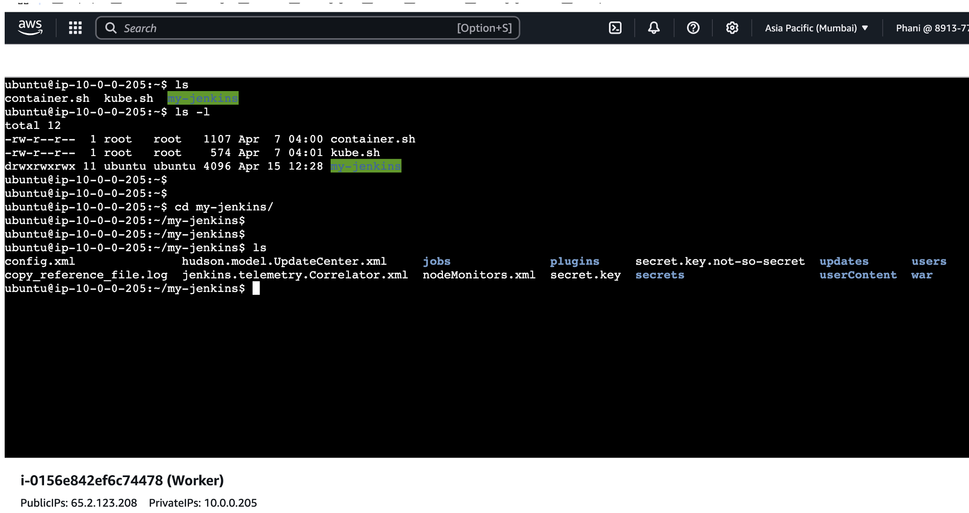
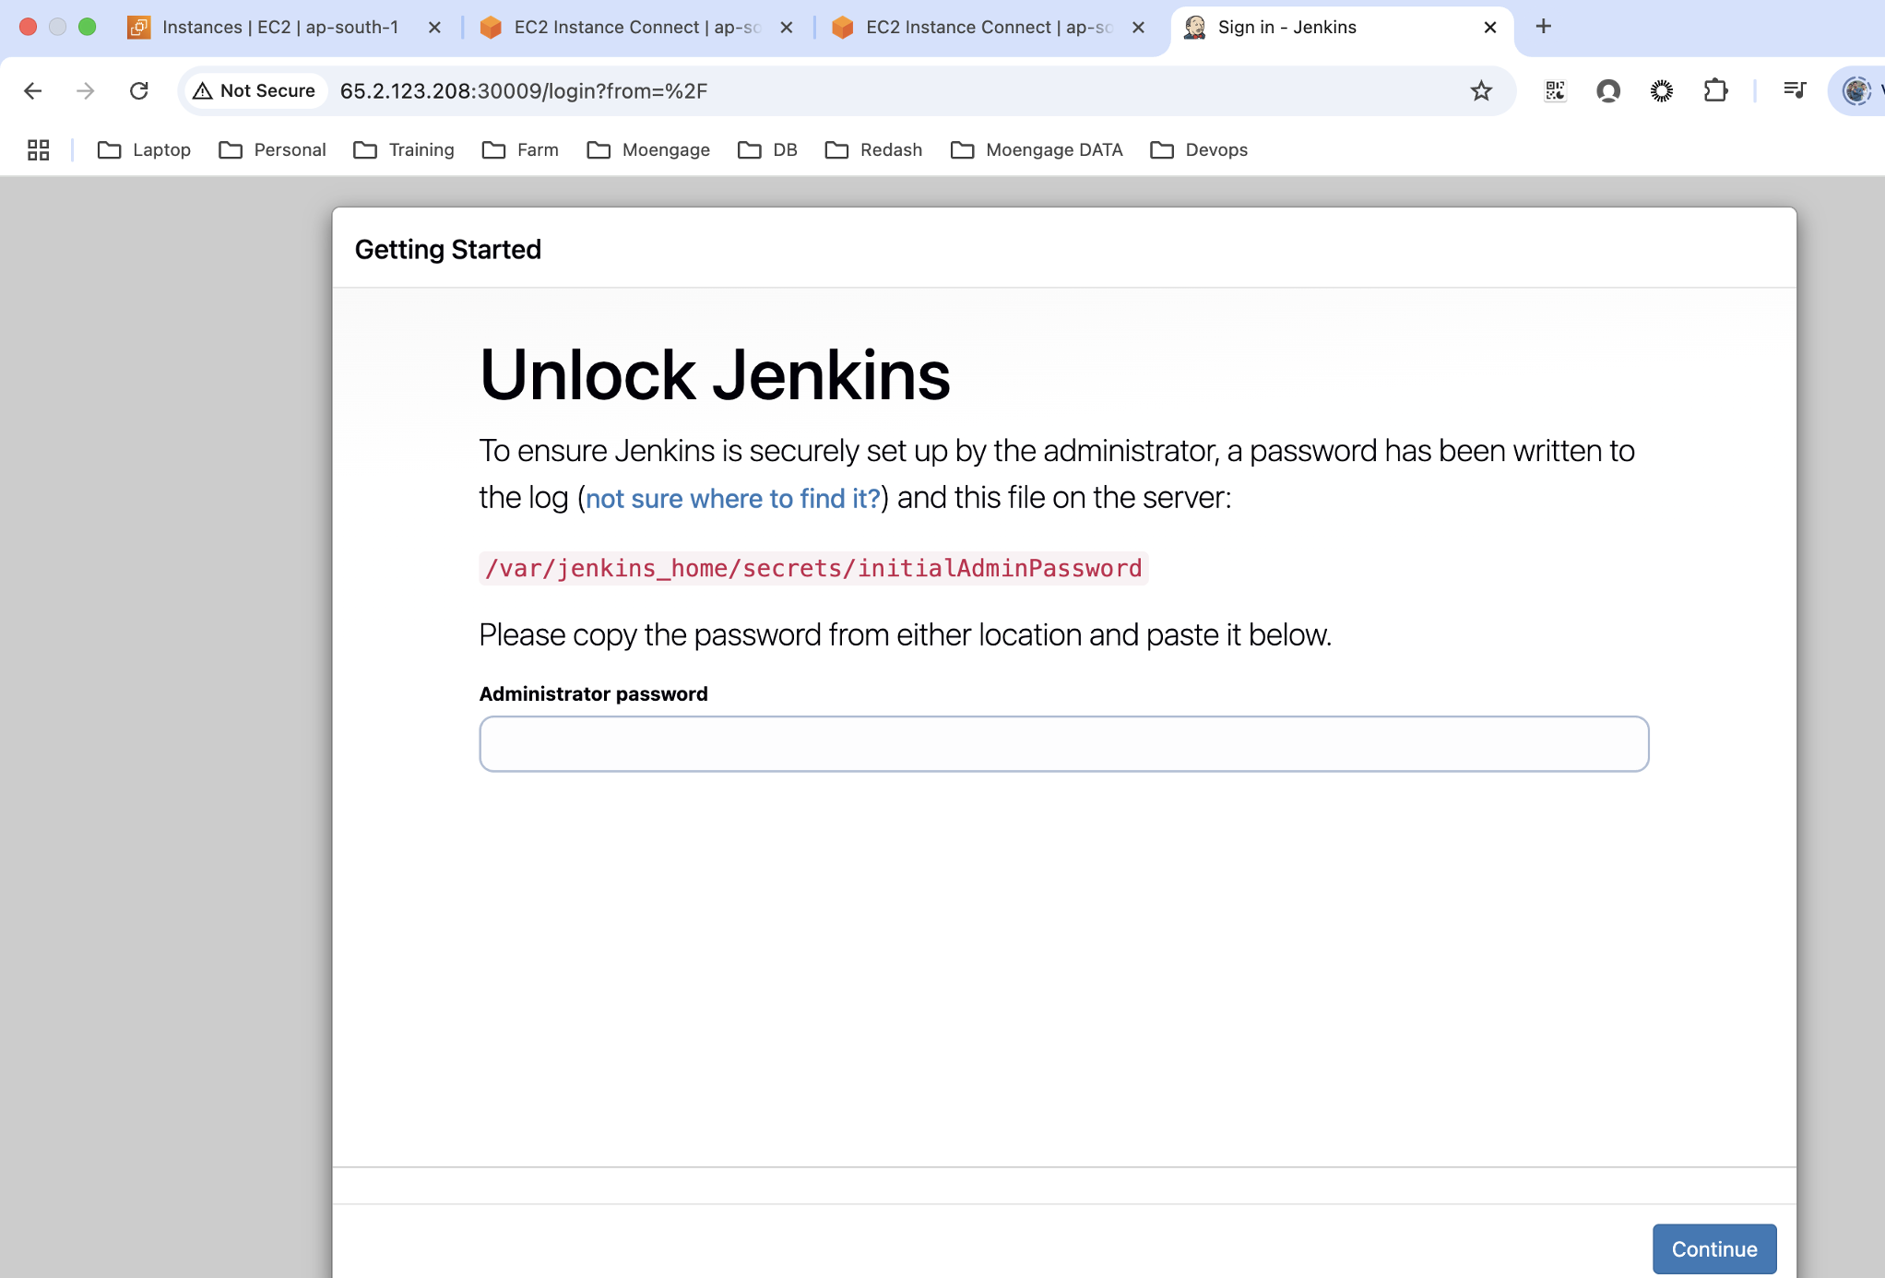
Day 106: Kubernetes (K8s)
Static Volumes
PV and PVC
PV is used to create a volume and we use PVC to claim the volume
22_PersistentVolume.yml
apiVersion: v1
kind: PersistentVolume
metadata:
name: local-pv
spec:
capacity:
storage: 1Gi
accessModes:
- ReadWriteOnce
persistentVolumeReclaimPolicy: Retain
storageClassName: manual
hostPath:
path: /mnt/data
nodeAffinity:
required:
nodeSelectorTerms:
- matchExpressions:
- key: topology.kubernetes.io/region
operator: In
values:
- ap-south-1

Kubectl apply -f 22_PersistentVolume.yml
kubectl get pv
23_PVC.yml
apiVersion: v1
kind: PersistentVolumeClaim
metadata:
name: local-pvc
spec:
accessModes:
- ReadWriteOnce
resources:
requests:
storage: 1Gi
storageClassName: manual

Kubectl apply -f 23_PVC.yml
kubectl get pvc
24_PVC_POD.yml
apiVersion: apps/v1
kind: Deployment
metadata:
name: jenkins-replicaset-deployment
labels:
app: my-jenkins
spec:
replicas: 3
strategy:
type: RollingUpdate
rollingUpdate:
maxSurge: 2
maxUnavailable: 0
selector:
matchLabels:
app: my-jenkins
template:
metadata:
labels:
app: my-jenkins
spec:
volumes:
- name: jenkins-volume
persistentVolumeClaim:
claimName: local-pvc
containers:
- name: jenkins
image: jenkins/jenkins:latest
volumeMounts:
- mountPath: /var/jenkins_home
name: jenkins-volume
securityContext:
runAsUser: 0
fsGroup: 0

Kubectl apply -f 24_PVC_POD.yml
Kubectl get pods
Static efs:
Install the EFS CSI Driver (if not already installed)helm repo add aws-efs-csi-driver https://kubernetes-sigs.github.io/aws-efs-csi-driver/
helm upgrade --install aws-efs-csi-driver aws-efs-csi-driver/aws-efs-csi-driver \
--namespace kube-system \
--set controller.serviceAccount.create=true \
--set controller.serviceAccount.name=efs-csi-controller-sa

Create an efs on cloud, and use the efs id in the manifest file. Here all the data will be stored on the efs.
25_PV_Static_EFS.yml
apiVersion: v1
kind: PersistentVolume
metadata:
name: efs-static-pv
spec:
capacity:
storage: 5Gi
volumeMode: Filesystem
accessModes:
- ReadWriteMany
persistentVolumeReclaimPolicy: Retain
storageClassName: ""
csi:
driver: efs.csi.aws.com
volumeHandle: fs-04b7a10a3c9afcdc3

26_PVC_Static_EFS.yml
apiVersion: v1
kind: PersistentVolumeClaim
metadata:
name: efs-static-pvc
spec:
accessModes:
- ReadWriteMany
resources:
requests:
storage: 5Gi
storageClassName: "" # Must match the PV

27_PVC_POD_EFS.yml
apiVersion: apps/v1
kind: Deployment
metadata:
name: jenkins-replicaset-deployment
labels:
app: my-jenkins
spec:
replicas: 3
strategy:
type: RollingUpdate
rollingUpdate:
maxSurge: 2
maxUnavailable: 0
selector:
matchLabels:
app: my-jenkins
template:
metadata:
labels:
app: my-jenkins
spec:
volumes:
- name: jenkins-volume
persistentVolumeClaim:
claimName: efs-static-pvc
containers:
- name: jenkins
image: jenkins/jenkins:latest
volumeMounts:
- mountPath: /var/jenkins_home
name: jenkins-volume
securityContext:
runAsUser: 0
fsGroup: 0

Static EBS:
Create EBS manually
helm repo add aws-ebs-csi-driver https://kubernetes-sigs.github.io/aws-ebs-csi-driver/
helm repo updatehelm upgrade --install aws-ebs-csi-driver aws-ebs-csi-driver/aws-ebs-csi-driver \
--namespace kube-system \
--set controller.serviceAccount.create=true \
--set controller.serviceAccount.name=ebs-csi-controller-sa

kubectl get pods -A

29_PV_Static_EBS.yml
apiVersion: v1
kind: PersistentVolume
metadata:
name: ebs-static-pv
spec:
capacity:
storage: 5Gi
volumeMode: Filesystem
accessModes:
- ReadWriteOnce
persistentVolumeReclaimPolicy: Retain
storageClassName: ""
awsElasticBlockStore:
volumeID: vol-0e544b6d77576b3ad
fsType: ext4

30_PVC_Static_EBS.yml
apiVersion: v1
kind: PersistentVolumeClaim
metadata:
name: ebs-static-pvc
spec:
accessModes:
- ReadWriteOnce
resources:
requests:
storage: 5Gi
storageClassName: ""

31_PVC_POD_EBS.yml
apiVersion: apps/v1
kind: Deployment
metadata:
name: jenkins-replicaset-deployment
labels:
app: my-jenkins
spec:
replicas: 3
strategy:
type: RollingUpdate
rollingUpdate:
maxSurge: 2
maxUnavailable: 0
selector:
matchLabels:
app: my-jenkins
template:
metadata:
labels:
app: my-jenkins
spec:
volumes:
- name: jenkins-volume
persistentVolumeClaim:
claimName: ebs-static-pvc
containers:
- name: jenkins
image: jenkins/jenkins:latest
volumeMounts:
- mountPath: /var/jenkins_home
name: jenkins-volume
securityContext:
runAsUser: 0
fsGroup: 0

32_EBS__Service.yml
apiVersion: v1
kind: Service
metadata:
name: jenkinsservice-nodeport-test1
spec:
type: NodePort
selector:
app: my-jenkins
ports:
- protocol: TCP
port: 8080
targetPort: 8080
nodePort: 30004

Persistent volume:
Piece of storage in the cluster that has been provisioned by the administrator or dynamically provisioned using storage classes. It is a resource in the cluster just like a node in the cluster resource.
PVs are volumes plugins like volumes, but have a life cycle independent of any individual pod that uses the PV.
K8s persistent volume has the following attributes:
It is provisioned either dynamically or by an administrator.
Created with a particular filesystem.
Has a particular size.
Has identifying characteristics such as volume ids and a name.
Persistent volume claim (PVC):
PVC is a request for storage by a user it is similar to Pod. Pods consume node resources and PVCs consume PV resources. Pods can request specific level of requests (CPU & Memory). Claims can request specific size and access modes (example: they can be mounted once read/write or many times read/write).
Persistent volume claim describes the amount and characteristics of the storage required by the pod, finds any matching persistent volumes and claims this.
K8s persistent volume remains available outside of the pod life cycle this means that the volume will remain even after the pod is deleted. It is available to claim by another pod if required and the data is retained.
Day 107: Kubernetes (K8s)
Dynamic provisning
We will be using the EBS here and we need the below policy to be attached on all the nodes:
AmazonEBSCSIDriverPolicy
Commands to install ebs-csi driver
helm repo add aws-ebs-csi-driver https://kubernetes-sigs.github.io/aws-ebs-csi-driver/
helm repo updatehelm upgrade --install aws-ebs-csi-driver aws-ebs-csi-driver/aws-ebs-csi-driver \
--namespace kube-system \
--set controller.serviceAccount.create=true \
--set controller.serviceAccount.name=ebs-csi-controller-sa

kubectl get pods -A

Here we don’t create the PV, we will create the PVC and storage class
PVC will make use of the storage class to create the EBS volume
33_EBS_storageclass.yml
apiVersion: storage.k8s.io/v1
kind: StorageClass
metadata:
name: ebs-sc
provisioner: ebs.csi.aws.com
parameters:
type: gp3
fsType: ext4
volumeBindingMode: WaitForFirstConsumer

34_PVC_EBS_Storageclass.yml
apiVersion: v1
kind: PersistentVolumeClaim
metadata:
name: my-pvc
spec:
accessModes:
- ReadWriteOnce # Or ReadWriteMany if your driver supports it (e.g. EFS)
resources:
requests:
storage: 5Gi
storageClassName: ebs-sc

35_dynamic_POD_EBS.yml
apiVersion: apps/v1
kind: Deployment
metadata:
name: jenkins-replicaset-deployment
labels:
app: my-jenkins
spec:
replicas: 3
strategy:
type: RollingUpdate
rollingUpdate:
maxSurge: 2
maxUnavailable: 0
selector:
matchLabels:
app: my-jenkins
template:
metadata:
labels:
app: my-jenkins
spec:
volumes:
- name: jenkins-volume
persistentVolumeClaim:
claimName: my-pvc
containers:
- name: jenkins
image: jenkins/jenkins:latest
volumeMounts:
- mountPath: /var/jenkins_home
name: jenkins-volume
securityContext:
runAsUser: 0
fsGroup: 0

A new EBS will be created on the AWS
kubectl get pv pvc-ba39dcab-2f8d-45a3-9651-e2559126adf2 -oyaml

https://github.com/kubernetes-sigs/aws-efs-csi-driver/blob/master/examples/kubernetes/dynamic_provisioning/specs/storageclass.yaml

Day 108: Kubernetes (K8s)
Configmap
Secrets
Kubernetes Secrets:
A secrete is an object that contains a small amount of sensitive data such as password, a token or a key.
To use a Secret, a Pod needs to reference the Secret. A Secret can be used with a Pod in three ways:
As files in a volume mounted on one or more of its containers.
As container environment variable.
By the kubelet when pulling images for the Pod.

ConfigMaps: Configmaps are similar to secret.
They can be created and shared in the containers in the same way. The only big difference between them is base64 encoding obfuscation.
Configmaps are intended for non-sensitive data, configuration data like config files and environment variables and are a great way to create customized running service from generic container images.
Day 109: Kubernetes (K8s)
StatefulSet:
- Any application that depends on current state of the application, than we will be using the statefulset.
https://www.loft.sh/blog/kubernetes-statefulset-examples-and-best-practices
- It has to be deployed with the service with cluster IP as none
- The cluster ip with none is called as headless service, this is used to communicate between the pods
- Volumeclaimmount will create the pv and pvc internally
- Here all the pods will have different volumes, network, pv and pvc
- Auto healing of the pods, sync between the volumes will be taken care by the stateful set
- Usually we will use this object for databases

1.yml
apiVersion: v1
kind: Service
metadata:
name: nginx
labels:
app: nginx
spec:
ports:
- port: 80
name: web
clusterIP: None
selector:
app: nginx
---
apiVersion: apps/v1
kind: StatefulSet
metadata:
name: web
spec:
selector:
matchLabels:
app: nginx # has to match .spec.template.metadata.labels
serviceName: "nginx"
replicas: 3 # by default is 1
minReadySeconds: 10 # by default is 0
template:
metadata:
labels:
app: nginx # has to match .spec.selector.matchLabels
spec:
terminationGracePeriodSeconds: 10
containers:
- name: nginx
image: registry.k8s.io/nginx-slim:0.24
ports:
- containerPort: 80
name: web
volumeMounts:
- name: www
mountPath: /usr/share/nginx/html
volumeClaimTemplates:
- metadata:
name: www
spec:
accessModes: [ "ReadWriteOnce" ]
storageClassName: "standard"
resources:
requests:
storage: 1Gi

Jobs:
What is a Kubernetes Job?
A Job runs a pod (or multiple pods) to completion. It ensures that a specified number of pods successfully terminate.
Use when:You need to run a batch process like image conversion, database migration, file upload, etc.It should run once and exit.
job.yml
apiVersion: batch/v1
kind: Job
metadata:
name: hello-job
spec:
template:
spec:
containers:
- name: hello
image: busybox
command: ["echo", "Hello from Kubernetes Job"]
restartPolicy: Never
backoffLimit: 3

Cronjob:
What is a CronJob?
A CronJob is for scheduled jobs, similar to Linux cron.
Use when:
You want to run something periodically (every hour, every day, etc.).
It wraps a Job and runs it on a schedule.
Cronjob.yml
apiVersion: batch/v1
kind: CronJob
metadata:
name: hello-cronjob
spec:
schedule: "*/5 * * * *" # every 5 minutes
jobTemplate:
spec:
template:
spec:
containers:
- name: hello
image: busybox
command: ["echo", "Hello from CronJob"]
restartPolicy: OnFailure

Field | Description
completions | Total number of pods to complete the job
parallelism | Number of pods to run in parallel
backoffLimit | Number of retries before marking as failed
activeDeadlineSeconds | Max time job can run before timeout
restartPolicy | Usually Never or OnFailure

Kubernetes RBAC (Role-Based Access Control) is a way to control who can do what in your cluster. It allows you to define fine-grained permissions based on users, groups, or service accounts.
RBAC Works (Key Components):
Component | What it Does
Role | Defines permissions within a namespace
ClusterRole | Defines permissions across all namespaces (cluster-wide)
RoleBinding | Assigns a Role to a user/service account in a namespace
ClusterRoleBinding | Assigns a ClusterRole globally

Day 110: Kubernetes (K8s)
https://kubernetes.io/docs/reference/access-authn-authz/rbac/

https://kubernetes.io/docs/tasks/configure-pod-container/configure-liveness-readiness-startup-probes/

https://github.com/sebinxavi/kubernetes-readiness/tree/master
Liveliness
Liveness and Readiness probes are used to control the health of an application running inside a Pod’s container. Both are very similar in functionality, and usage.
Readiness probe:
In some cases, we would like our applications to be alive but not serve the traffic unless some conditions are met. In such cases we use readiness probe if the condition inside readiness probe passes, then only our applications can serve the traffic.
Readiness probe runs on the container during its whole life cycle.
Note: liveliness probe doesn’t wait for readiness probe to succeed. If you want to wait before executing a liveliness probe you should use a initial delay seconds.
initialDelaySeconds: 3
This is the delay which tells kubelet to wait for 3 seconds before performing the first probe
periodSeconds: 5
This field specifies that kubelet should perform a probe every 5 seconds.
Both liveliness and readiness probe are used to control the health of the application. Failing liveliness probe will restart the container, whereas failing readiness probe will stop our application from serving the traffic.
Day 111: Kubernetes (K8s)
Network
Day 112: Kubernetes (K8s)
Ingress-Ngnix-controller
kubectl apply -f https://raw.githubusercontent.com/kubernetes/ingress-nginx/controller-v1.10.0/deploy/static/provider/cloud/deploy.yaml
Day 113: Kubernetes (K8s)
Istio

Day 114: Kubernetes (K8s)

https://helm.sh/docs/intro/install/
https://helm.sh/docs/chart_template_guide/getting_started/
helm create 1_jenkins_chart – to create the helm chart
- This will create a folder with the provide name 1_jenkins_chart, which will have sub folders like Chart.yaml charts templates values.yaml
- Values.yml will be used to store the variable
- Templates will have the manifest files
helm install myjenkins .
helm install myjenkins ./ 1_jenkins_chart
helm ls
kubectl get pods
helm package 1_jenkins_chart/
ls
curl -uphani.nandigam@moengage.com:cmVmdGtuOjAxOjE3NzY4NjUyMDY6WWZibEFOZUd2T2JTZnNDb2kyMXpWTDJsTEhu -T 1_jenkins_chart-0.1.0.tgz https://trialpexgbj.jfrog.io/artifactory/jenkins-helm/1_jenkins_chart-0.1.0.tgz
helm ls
helm history myjenkins
helm get manifest jenkinsvariables --revision 2
helm get manifest jenkinsvariables --revision 1
helm get all jenkinsvariables --revision 1

Day 115: Kubernetes (K8s)
Argocd:
https://www.arthurkoziel.com/setting-up-argocd-with-helm/
Argo CD installation commands:>>>
helm install argo-cd charts/argo-cd/ 374 helm repo add argo https://argoproj.github.io/argo-helm
375 helm repo update
376 kubectl create namespace argocd
377 helm install argocd argo/argo-cd --namespace argocd --set server.service.type=LoadBalancer
378 kubectl get crds
379 kubectl get crds | grep argo
380 kubectl delete crds applications.argoproj.io appprojects.argoproj.io
381 helm install argocd argo/argo-cd --namespace argocd --set server.service.type=LoadBalancer
382 kubectl get svs
383 kubectl get svc
384 kubectl get svc -n argocd
385 kubectl -n argocd get secret argocd-initial-admin-secret -o jsonpath="{.data.password}" | base64 -d
386 kubectl create namespace istio-system
387 kubectl get ns
388 kubectl get pods
389 kubectl get pods -n argocd
390 kubectl get pods -A
391 kubectl get pods
392 kubectl get pods -n istio-systems
393 kubectl get pods -n istio-system
394 helm ls -A
>>>

Day 116: Kubernetes (K8s)
Canary and blue green statergies
VPA and HPA and CA
https://www.kubecost.com/kubernetes-autoscaling/kubernetes-hpa

Day 117: Kubernetes (K8s)
Kuberentes upgrade

